Orsolino, Abigail A.
CITCS-1C
Part 1: Design an IP Addressing Scheme
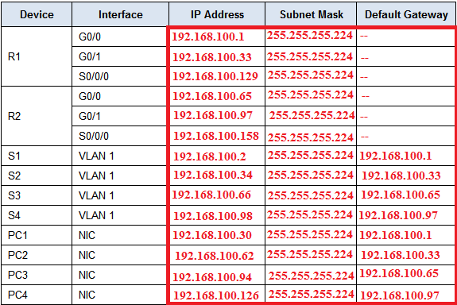
Part 2: Assign IP Addresses to Network Devices and Verify Connectivity
Part 1: Design an IP Addressing Scheme
Step 1: Subnet the 192.168.100.0/24 network into the appropriate number of subnets.
a. Based on the topology, how many subnets are needed? - 5 subnets are needed
b. How many bits must be borrowed to support the number of subnets in the topology table?- 3 must be borrowed to support the number of subnets
c. How many subnets does this create? - It can create 8 subnets
d. How many usable hosts does this create per subnet? - per subnet it can create 30 usable hosts
Note: If your answer is less than the 25 hosts required, then you borrowed too many bits.
e. Calculate the binary value for the first five subnets. The first subnet is already shown.
Net 0: 192 . 168 . 100 . 0 0 0 0 0 0 0 0
Net 1: 192 . 168 . 100 . 0010 0000
Net 2: 192 . 168 . 100 . 0100 0000
Net 3: 192 . 168 . 100 . 0110 0000
Net 4: 192 . 168 . 100 . 1000 0000
f. Calculate the binary and decimal value of the new subnet mask.
11111111.11111111.11111111. 1110 0000
255 . 255 . 255 . 224
g. Fill in the Subnet Table, listing the decimal value of all available subnets, the first and last usable host address, and the broadcast address. Repeat until all addresses are listed.
Step 2: Assign the subnets to the network shown in the topology.
a. Assign Subnet 0 to the LAN connected to the GigabitEthernet 0/0 interface of R1:192.168.100.0/27
b. Assign Subnet 1 to the LAN connected to the GigabitEthernet 0/1 interface of R1:192.168.100.32/27
c. Assign Subnet 2 to the LAN connected to the GigabitEthernet 0/0 interface of R2:192.168.100.64/27
d. Assign Subnet 3 to the LAN connected to the GigabitEthernet 0/1 interface of R2:192.168.100.96/27
e. Assign Subnet 4 to the WAN link between R1 to R2:192.168.100.128/27
Step 3: Document the addressing scheme.
Fill in the Addressing Table using the following guidelines:
a. Assign the first usable IP addresses to R1 for the two LAN links and the WAN link.
b. Assign the first usable IP addresses to R2 for the LANs links. Assign the last usable IP address for the WAN link.
c. Assign the second usable IP addresses to the switches.
d. Assign the last usable IP addresses to the hosts.
Part 2: Assign IP Addresses to Network Devices and Verify Connectivity
Most of the IP addressing is already configured on this network. Implement the following steps to complete the addressing configuration.
Step 1: Configure IP addressing on R1 LAN interfaces.
Step 2: Configure IP addressing on S3, including the default gateway.
Step 3: Configure IP addressing on PC4, including the default gateway.
Step 4: Verify connectivity.

